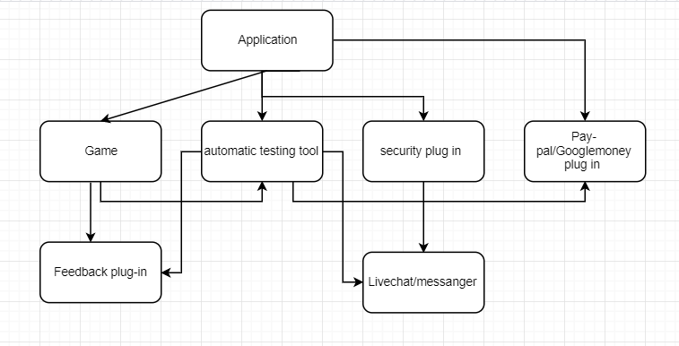

Integration test Hybrid (Top-down and bottom-up): We decided to use a hybrid method to perform an integration testing because it is more suitable for our project. Most of the plugins are going to interact with each other and it is important to make sure they are functioning correctly:

1. First, we are going to test a game, feedback and live chat together
2. Second, Google pay and security
3. Security, game and feedback etc.
4. And finally, we are running all the units and the test is our automatic testing tool is working (at this point we should have an idea what units are running properly and what bugs we have to test it)
5. Test slubs will be used to substitute missing units.